**Modul 10**

Nama : Andrias Sigid W.R

NIM : L200144010

Percobaan 1

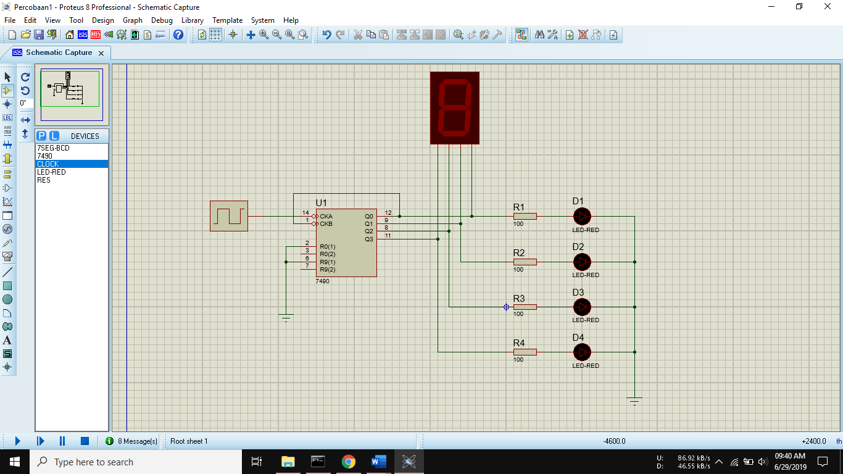

|  |  |  |  |  |  |
| --- | --- | --- | --- | --- | --- |
|  | Output LED | | | | Output Seven Segment |
| D1 | D2 | D3 | D4 |
| 1 | L | L | L | L | 0 |
| 2 | H | L | L | L | 1 |
| 3 | L | H | L | L | 2 |
| 4 | H | H | L | L | 3 |
| 5 | L | L | H | L | 4 |
| 6 | H | L | H | L | 5 |
| 7 | L | H | H | L | 6 |
| 8 | H | H | H | L | 7 |
| 9 | L | L | L | H | 8 |
| 10 | H | L | L | H | 9 |
| 11 | L | L | L | L | 0 |
| 12 | H | L | L | L | 1 |
| 13 | L | H | L | L | 2 |

Percobaan 2

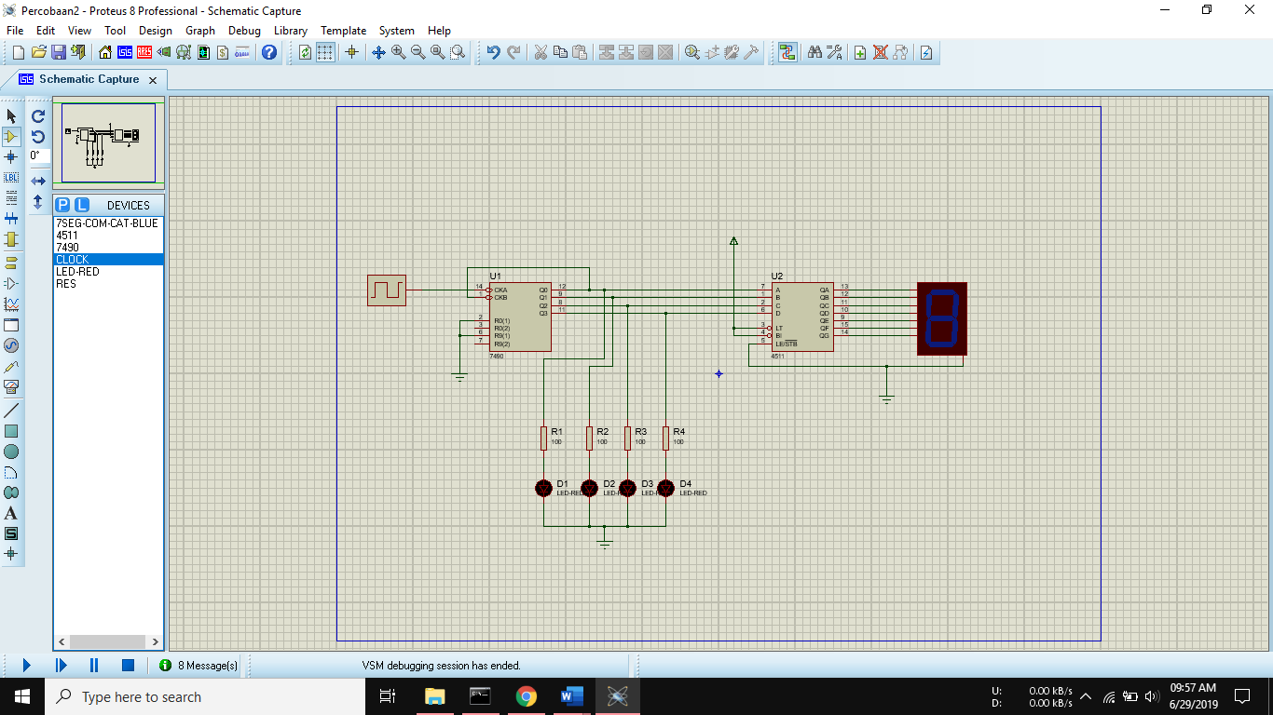

|  |  |  |  |  |  |
| --- | --- | --- | --- | --- | --- |
|  | Output LED | | | | Output Seven Segment |
| D1 | D2 | D3 | D4 |
| 1 | L | L | L | L | 0 |
| 2 | H | L | L | L | 1 |
| 3 | L | H | L | L | 2 |
| 4 | H | H | L | L | 3 |
| 5 | L | L | H | L | 4 |
| 6 | H | L | H | L | 5 |
| 7 | L | H | H | L | 6 |
| 8 | H | H | H | L | 7 |
| 9 | L | L | L | H | 8 |
| 10 | H | L | L | H | 9 |
| 11 | L | L | L | L | 0 |

4.

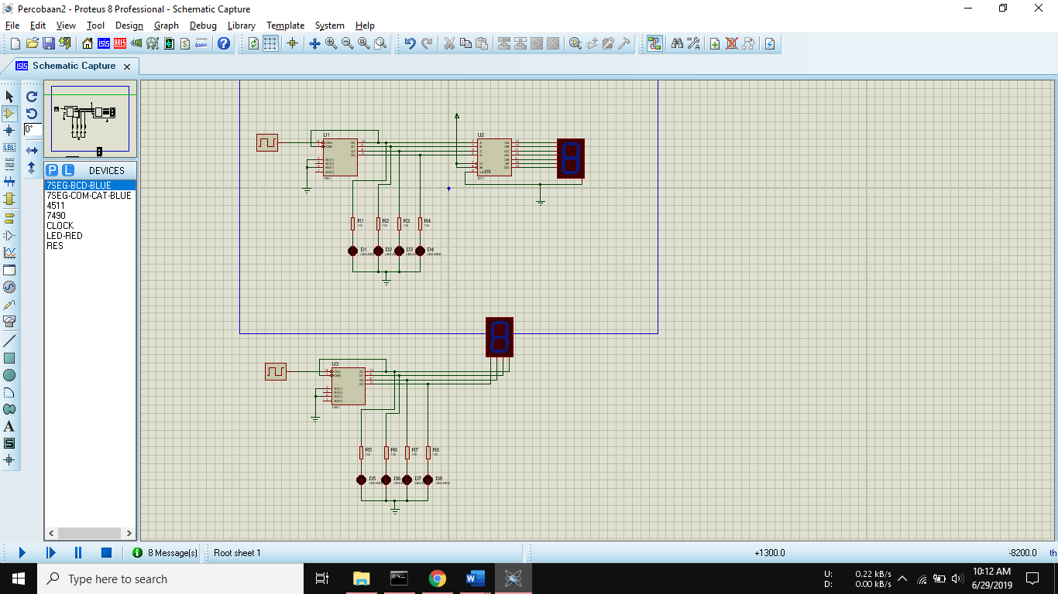

7seg-BCD sama dengan BCD-to-7segment decoder